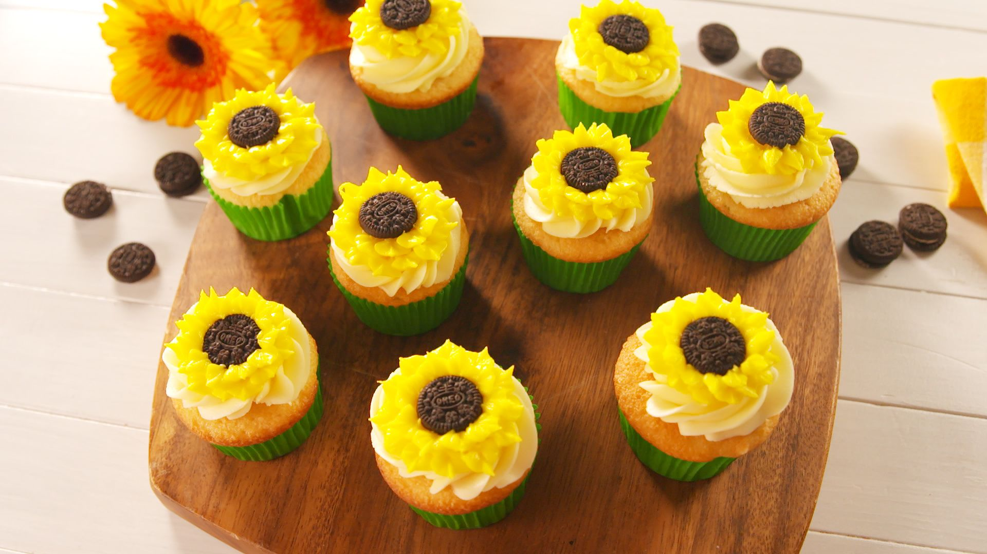

COFFEE

COOKIES $2

CAKES $3

CUPCAKES $3

CUPCAKES $4

CAKE SLICE $ 5

WHOLE CAKES $5

FEET $4

ICE CREAM $6

DONUTS $3

LOREM IPSUM $8

LOREM IPSUM $7

926 Prospect, City • 585 125 5689

WWW. SITE.COM

Without

WEEKEND

06-23