 |  |  |  |  | NAME
 |  |  |  |  | Summer 2020 Collection
 |  |  | 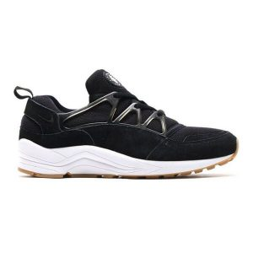 | DUMMY PRODUCT #1 |  |  | 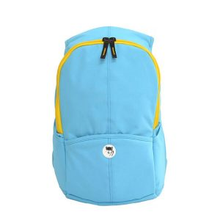 | DUMMY PRODUCT #2
 |  |  |  | ID: 202256 |  |  |  | ID: 202250
 |  |  |  | Wholesale Price: |  |  |  | Wholesale Price:
 |  |  |  | $45.99 |  |  |  | $32.99
 |  |  |  | Materials: |  |  |  | Materials:
 |  |  |  | Rubber, Leather, Synthetics |  |  |  | Synthetics
 |  |  |  | Colours: |  |  |  | Colours:
 |  |  |  | Black/Grey |  |  |  | Blue/Yellow
 |  |  | 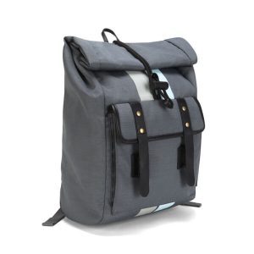 | DUMMY PRODUCT #3 |  |  | 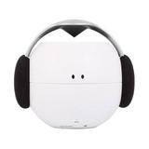 | DUMMY PRODUCT #4
 |  |  |  | ID: 202240 |  |  |  | ID: 202230
 |  |  |  | Wholesale Price: |  |  |  | Wholesale Price:
 |  |  |  | $69.99 |  |  |  | $29.99
 |  |  |  | Materials: |  |  |  | Materials:
 |  |  |  | Leather, Synthetics |  |  |  | Plastic/Synthetics
 |  |  |  | Colours: |  |  |  | Colours:
 |  |  |  | Black/Grey |  |  |  | Black/White/Grey
 |  |  | 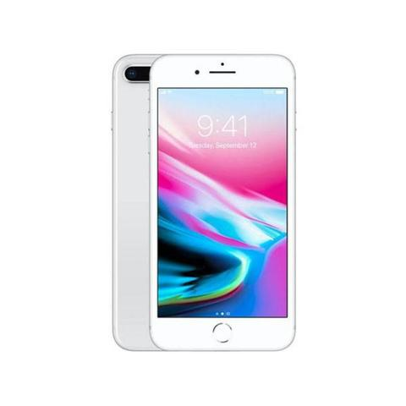 | DUMMY PRODUCT #5 |  |  | 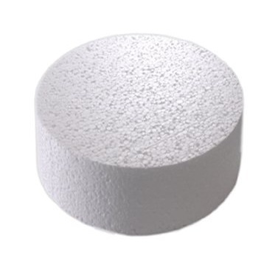 | DUMMY PRODUCT #6
 |  |  |  | ID: 202220 |  |  |  | ID: 202210
 |  |  |  | Wholesale Price: |  |  |  | Wholesale Price:
 |  |  |  | $125.99 |  |  |  | $4.99
 |  |  |  | Materials: |  |  |  | Materials:
 |  |  |  | Electrical device |  |  |  | Synthetics
 |  |  |  | Colours: |  |  |  | Colours:
 |  |  |  | White |  |  |  | White
 |  |  | 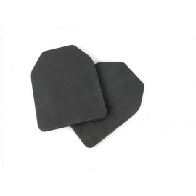 | DUMMY PRODUCT #7 |  |  | 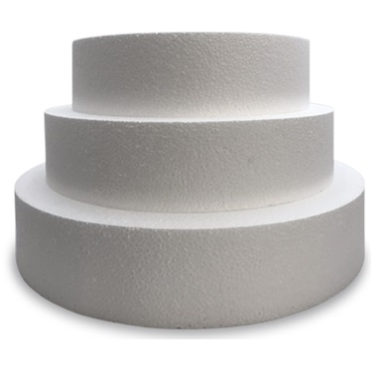 | DUMMY PRODUCT #8
 |  |  |  | ID: 202289 |  |  |  | ID: 202299
 |  |  |  | Wholesale Price: |  |  |  | Wholesale Price:
 |  |  |  | $12.99 |  |  |  | $22.99
 |  |  |  | Materials: |  |  |  | Materials:
 |  |  |  | Rubber |  |  |  | Synthetics
 |  |  |  | Colours: |  |  |  | Colours:
 |  |  |  | Black |  |  |  | White
 |  | www.companyname.com |  | COMPANY NAME |  |  |  | Phone: (555) 215 6589
 |  |  |  | The company's slogan that increases trust

