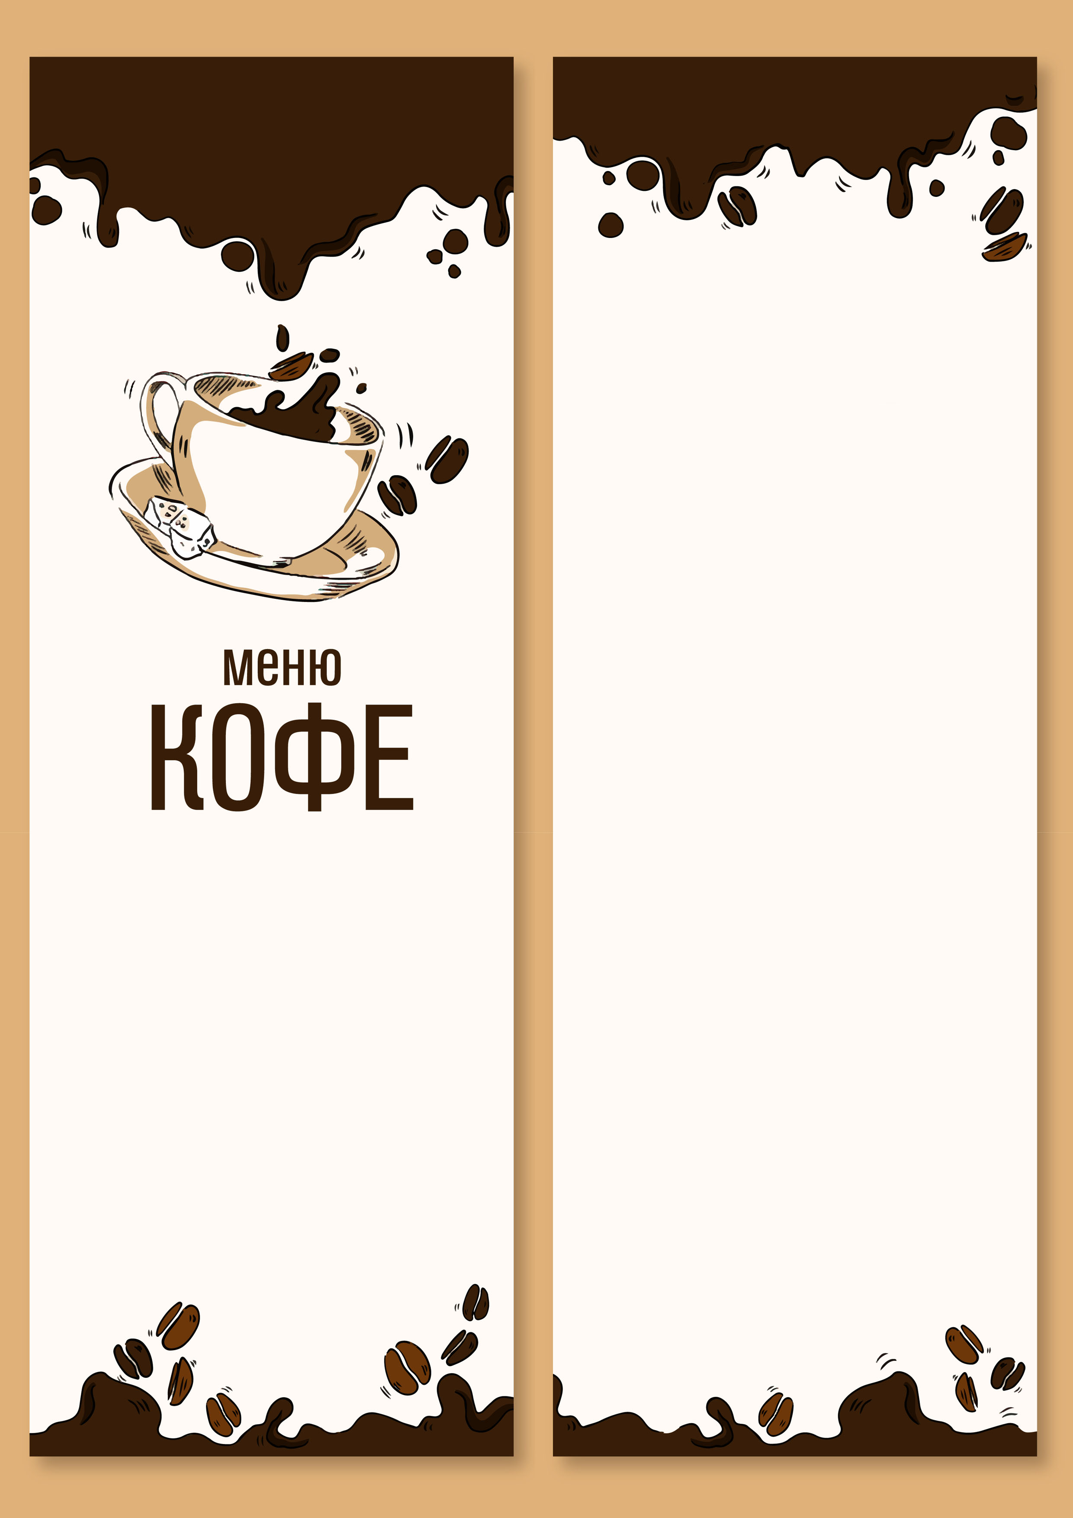café «Almaz»
ESPRESSO | 60 $
AMERICAN | 70 $
CAPPUCCINO | 100 $
LATTE | 120 $
ESPRESSO | 60 $
AMERICAN | 70 $
CAPPUCCINO | 100 $
LATTE | 120 $
ESPRESSO | 60 $
AMERICAN | 70 $
CAPPUCCINO | 100 $
LATTE | 120 $
AMERICAN | 70 $
CAPPUCCINO | 100 $
LATTE | 120 $
ESPRESSO | 60 $

